Cipher Nine

TW 314: Kriptologie Taak
Abrie Greeff
13557343
Introduction

The object of this assignment was to design a new block cipher that isn’t based on known ciphers. After carefully thinking about possibilities and guessing possible ways to make a safe cipher I decided that my cipher will be based on the beauty of the exclusive-or (xor) operation and the intricacies of matrices. Hence Cipher Nine was born.

The system was developed and tested on Matlab® Release 14. All accompanying code will be given in the appendices. This paper will define and discuss the inner workings of my system and its uses.
Definition

Cipher Nine 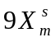is defined as the quintuple,
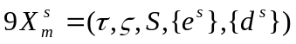
Where τ is all possible plaintexts formed using the ASCII table and ζ the corresponding cipher texts. S is all integer representations of binary values whose length is dividable by 4 and bigger or equal to 8 bits.

The encryption rule is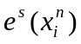where n is the amount of bits s consists of and i the index of every 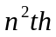 character in the text. For every x the characters are placed in a matrix of size with the first row being filled with the first n characters of x and the second with the next n and so forth. Thus a matrix 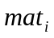is constructed which looks as follows
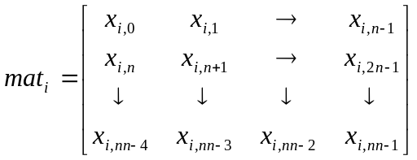
Next a sub key 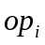 needs to be computed for each. This is done by examining the key. Every four bits starting from the least significant bit points to the lower four bits of a character on the main diagonal. The first four bits point to the first entry and so forth. When a one is found in the key the corresponding bit in the diagonal is stored as a bit in op. This search is conducted until 8 bits have been found or all the bits of the key have been checked. Now we have an 8 bit value. Next each’s transpose is taken and stored in. Now we compute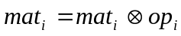accept on the values on the main diagonal. The entries in the matrices are now put back into a text string with the same method they were added, by starting with 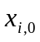 and ending with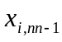. This whole text string is xor’ed with the least significant 8 bits of the key to conceal the main diagonals of the matrices. The text string that’s formed is the encoded text.

The decryption rule is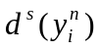. To decrypt the text first xor the cipher text with the 8 least significant bits of the key. Then construct all the matrices and compute all the sub keys. Now xor all the entries in the corresponding matrices with the sub key accept for the main diagonals. Lastly take the transpose of all the matrices and form a text string from the matrices as indicated above. This text is the deciphered text.

Please note that when there aren’t enough characters to fit into the last matrix when encoding pad the matrix with random values.
Key space

The key space associated with this cipher is computed as 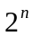where n is the amount of bits the key consists of. This key space is relatively small when small keys are chosen, for example a 16 bit encryption has only 65536 possible keys to search through. This however doesn’t present any problems because a person can easily make his key much larger. A brute force attack on a 128 bit encrypted text of length 4220 characters on my computer (3Ghz 64-bit CPU) will take roughly 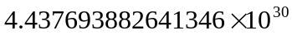 years to compute.

I therefore can conclude that Cipher Nine has a suitable key space. Brute force attacks will be discussed in Cipher-attacks which follow later.
Protocol

Always use the encryption and decryption rules defined in the definition. If you are not sure also refer to the Matlab® code in Appendix A-D and also the example that follows in the next section. When using this cipher make sure you use the correct key. When choosing the key always remember that the more bits the key consists of the more secure your text will be. This is very important because the cipher is used to secure your data and a big key will guarantee your data wouldn’t be compromised.

Example

To show how Cipher Nine works I will encrypt and decrypt the message:
“This code works” with a 16-bit key 54488 which in binary notation is 1101010011011000.

Encrypt

This means we need one 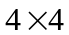matrix. The input text in ASCII is:
“84 104 105 115 32 99 111 100 101 32 119 111 114 107 115”
There needs to be one value padded to the string, I’ll use 87. The matrix is then constructed.

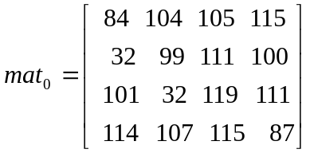

The transpose is computed.

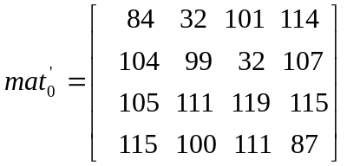

Next we need to compute the sub key. The values on the main diagonal are:
“84 99 119 87”

We split the key to see which bits we need,
84 99 119 87
1101 0100 1101 1000

The diagonal bit reprensantion with corresponding key entries is:

01010100 01100011 01110111 01010111
1101 0100 1101 1000
We need all the entries with corresponding ones, thus
01 0 0 01 1 0

The sub key is therefore 01000110₂ = 70₁₀ and xor’ing the matrix accept for the main diagonal entries with the sub key gives:

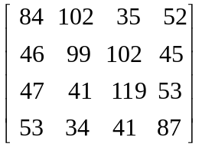

Lastly we xor this with the key’s 8 least significant bits 11010100₂ = 212₁₀.

This gives the following matrix:

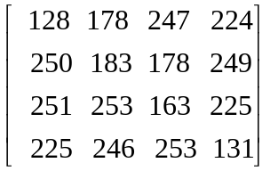

When we put this back into a text string the following cipher text is given:

“²÷àú·²ùûý£ááöý”

Decrypt
To decrypt we start by putting the message into a matrix:

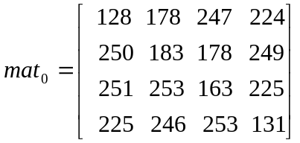

We xor with the 8 least significant bits of the key.

We work out the sub key 70 from the main diagonal.
Xor the values in the matrix accept for the main diagonal with 70.

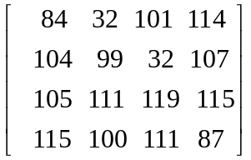

Compute the transpose.

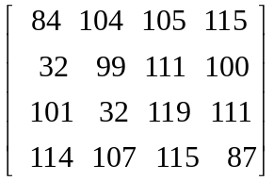

And put it in a string:

“This code worksW”

The cipher text decrypted correctly. The W is the character we padded.
Cipher-attacks

I computed on my computer how long it would take to run the decode algorithm on a text of length 4220 with a 16 bit encryption. I saw this took 0.4 seconds roughly and if you take the key space in to consideration it will take aproximately 7 hours to crack the code.

This is not acceptable for companies who may lose a lot of money when the code is cracked. However as the amount of bits increases the security increases more and Cipher Nine starts to shine. As I mentioned previously a 128 bit encryption will take years to crack. I can therefore say that Cipher Nine can’t be cracked by brute force. To see how long a given key’s brute force attack will take please consult Appendix E.

Logically the next step would be to see what happens when letter frequencies are taken.

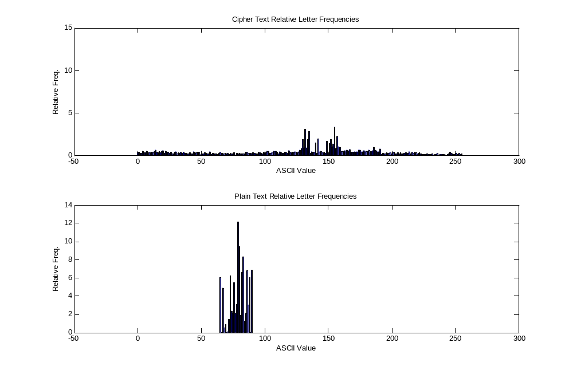
We see that the cipher text is nicely evened out over the whole ASCII table. There are a few values that have higher frequencies. I thought that maybe it will be possible to derive certain characters from those higher values. But this is not possible because every character is xor’ed with a value that is computed from n different other characters.

It is shown in the next graph how every character can go to different ASCII values.
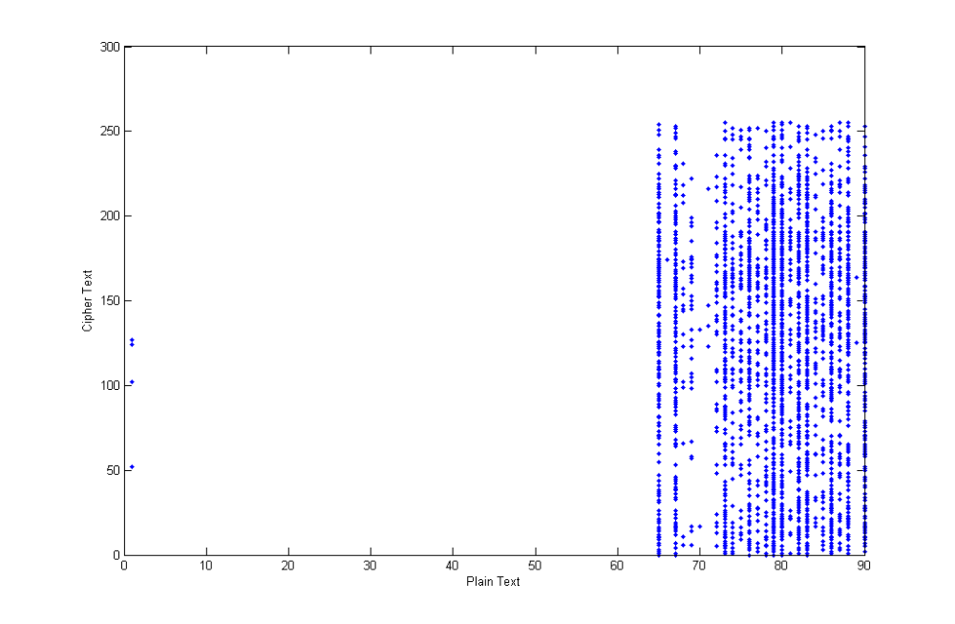
I can conclude that letter frequencies won’t work

When just one bit is changed in the key the characters all go to different values as is shown in the next graph.

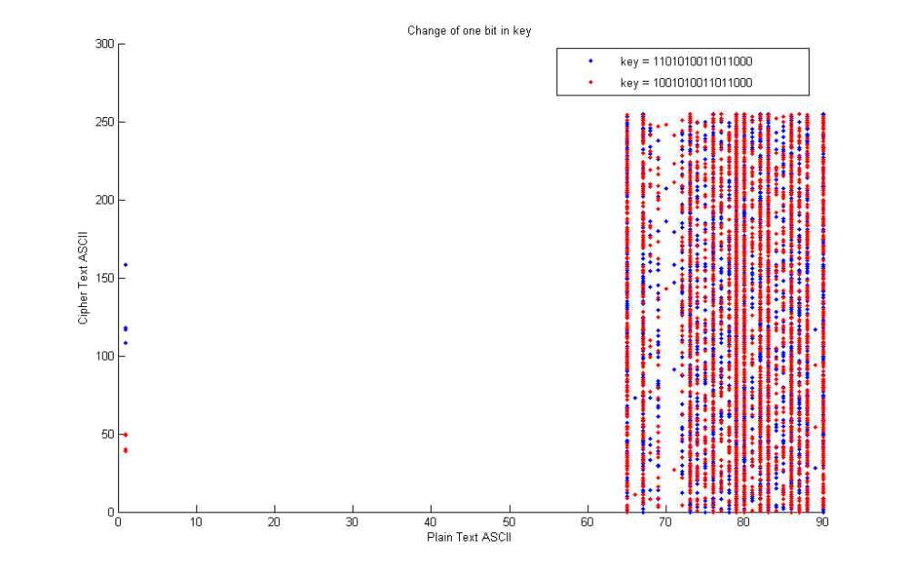

Thus a ciphertext-only attack can’t be done.

When the cripto-analyst has a plain text and cipher text that he knows was generated using the same key as the one he is trying to crack he will try the following steps.
For this example we will use the same text pair as in the example. Thus “This code works” and “²÷àú·²ùûý£ááöý” will be used. He then xor’s the first characters to obtain the least significant bits of the key.

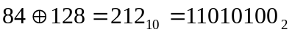
Then xor the whole cipher text with this value.
The following step would be to compute the length of the matrix. For every n we do look at which character will lie next on the diagonal for that length until that character corresponds to the same character in the plain text.
Now do the following operation
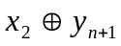
This will give the sub key for the first matrix. We also know the values of the main diagonal, so align the sub key with the lower bits to obtain the key that was used.

Thus Cipher Nine can be cracked using a known plain text/cipher text attack.

If a chosen plaintext is chosen that consists only of only one repeating character then the cipher can be cracked in less steps. Again the first characters are xor’ed to obtain the 8 least significant bits of the key. The second character is then xor’ed with this value to obtain the sub key. Because the main diagonal only consists of the same character the key can then easily be obtained.

If a chosen ciphertext attack is launched it is done exactly the same way as a chosen plaintext attack. Again make the cipher text the same repeating character. Just remember to choose the text length so that it fits exactly into a amount of matrices, because decode assumes the text is padded. The cipher text that is generated is the same as when the string is encoded. Thus to crack again use the same steps.

I can therefore conclude that Cipher Nine is secure but insecure when a crypto-analyst has access to the system so that he can use one of the above three methods.
Advantages and disadvantages

Advantages

The cipher text that is generated from plain text is safe and numerically secure for big keys. When letter frequencies is used it gives no information about the key or the plain text. A character never encodes to the same character for different texts with the same key and when only one bit is changed in a key the whole text is different. There is 256 different sub keys for any key.

Disadvantages

When a small key is used the system may be cracked relatively easy (8 bit or 16 bit keys) in under 8 hours. If cryptanalytic attacks is launched it may be broken.
Possible Safety Measures

When xor’ing with the 8 least significant bits of the key, rotate the bits by a certain amount. The matrix operation is very simple arithmetic. It may be possible to do more complicated matrix operations. The subkey always refer to the lower 4 bits. Possibly I can add a bit that defines if the sub key is computed from the lower or upper 4 bits. Restrict use to larger than 48 bit keys. A 32 bit key may be more than enough as this takes roughly 54 years to crack.
Appendix A

This is a Matlab® function that generates a vector that contains the actual key and its amount of matrices needed. The input is a vector [0 1 0 1 0] where the vector indicates 01010 in binary.

function [ret] = gen_key(key)
%return key in decimal and bit length divided by 4

s = size(key,2)/4;
key = bin2dec(num2str(key));
ret = [key s];
Appendix B

This is the Matlab® function that computes the sub key from the diagonal and the key. It returns the sub key when it’s calculated.

function [ret] = subkey(di,key)
%work out a sub key from a diagonal

di = di';
%index in bit
k=1;
%initialize bit
bit = zeros(1,8);
%get size
n = (size(di,2)*4);
%loop and get corresponding bits
for i=1:n
if bitget(key,n-i+1) == 1
bit(k) = bitget(di(ceil(i/4)),5-(mod(i-1,4)+1));
k = k+1;
end
end
%return bits
ret = bin2dec(num2str(bit));
Appendix C

This Matlab® code does the encoding of a plain text as described in the definition.

function [ret] = encode(teks,key)
%encode kriptoteks using key from gen_key

s = key(2);
key = key(1);

vect = double(teks);
n = size(vect,2);
amount = ceil(n/s^2);
index = 0;

for i = 0:(amount-1)

%compute a matrix
for row = 1:s
for col = 1:s
if (s^2*i + col + s*(row - 1)) <= n
m(row,col) = vect(s^2*i + col + s*(row - 1));
else
m(row,col) = round(rand*255);
end
end
end

%do operations
op = subkey(diag(m),key);
m = m';
m = bitxor(m,op);
for i=1:s
m(i,i) = bitxor(m(i,i),op);
end
%add to encoded vector
for row = 1:s
for col = 1:s
index = index+1;
e_vect(index) = m(row,col);
end
end
end
ret = char(bitxor(e_vect,bitshift(key,-(8*(s/2-1)))));

Appendix D

This Matlab® code does the decoding of a cipher text as described in the definition.

function [ret] = decode(kriptoteks,key)
%decode kriptoteks using key from gen_key

s = key(2);
key = key(1);

e_vect = bitxor(double(kriptoteks),bitshift(key,-(8*(s/2-1))));

n = size(e_vect,2);
amount = ceil(n/s^2);
index = 0;

for i = 0:(amount-1)

%compute a matrix
for row = 1:s
for col = 1:s
m(row,col) = e_vect(s^2*i + col + s*(row - 1));
end
end

%do operations
m = m';
op = subkey(diag(m),key);

m = bitxor(m,op);
for i=1:s
m(i,i) = bitxor(m(i,i),op);
end

%add to decoded vector
for row = 1:s
for col = 1:s
index = index+1;
vect(index) = m(row,col);
end
end
end
ret = char(vect);
Appendix E

This table gives the aproximate time it may take to crack a given key by brute force.

Key | Hours | Days | Years
8-bit | 0.028444 | 0.001185
16-bit | 7.281778 | 0.303407 | 0.000831253
24-bit | 1864.135 | 77.6723 | 0.212800812
32-bit | 477218.6 | 19884.11 | 54.47700781
40-bit | 1.22e08 | 5090332 | 13946.114
48-bit | 3.13e10 | 1.3e09 | 3570205.184
56-bit | 8.01e12 | 3.34e11 | 913972527
64-bit | 2.05e15 | 8.54e13 | 2.33977e11
96-bit | 8.8e24 | 3.67e23 | 1.00492e21
128-bit | 3.78e34 | 1.58e33 | 4.31611e30
192-bit | 6.97e53 | 2.91e52 | 7.96182e49
256-bit | 1.28e73 | 5.36e71 | 1.4687e69
512-bit | 1.5e150 | 6.2e148 | 1.7006e146

References

Introduction to Cryptology by JH van Vuuren & D van Greunen

